# Jenkins task-2

1. Configure 2 slave machines in Jenkins master.

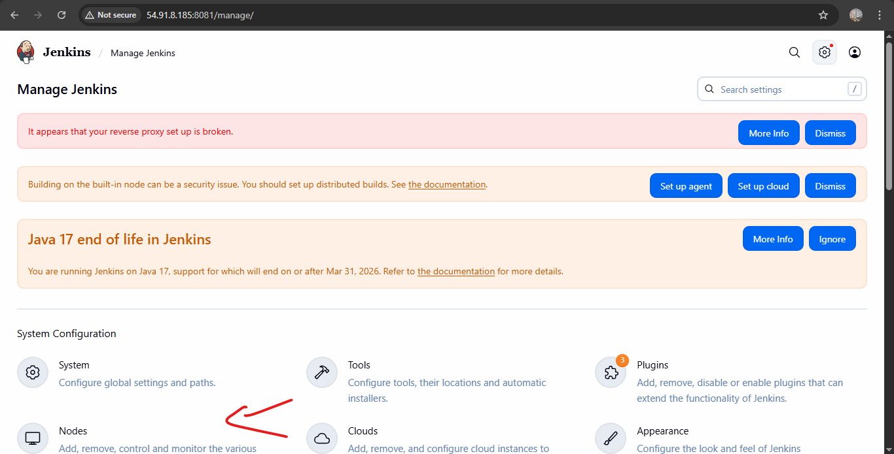

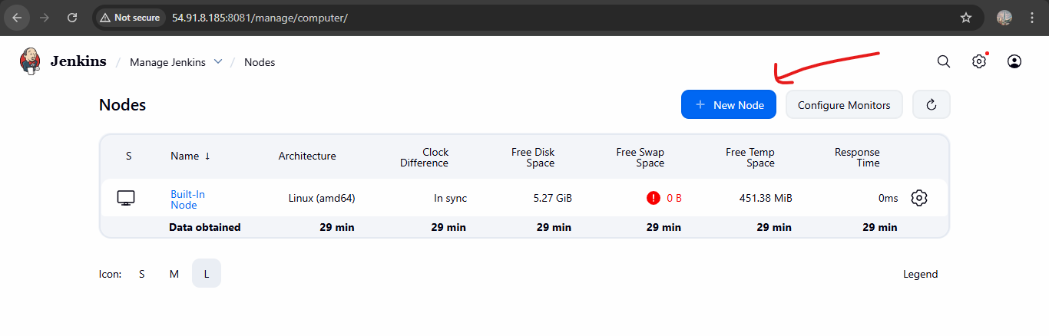

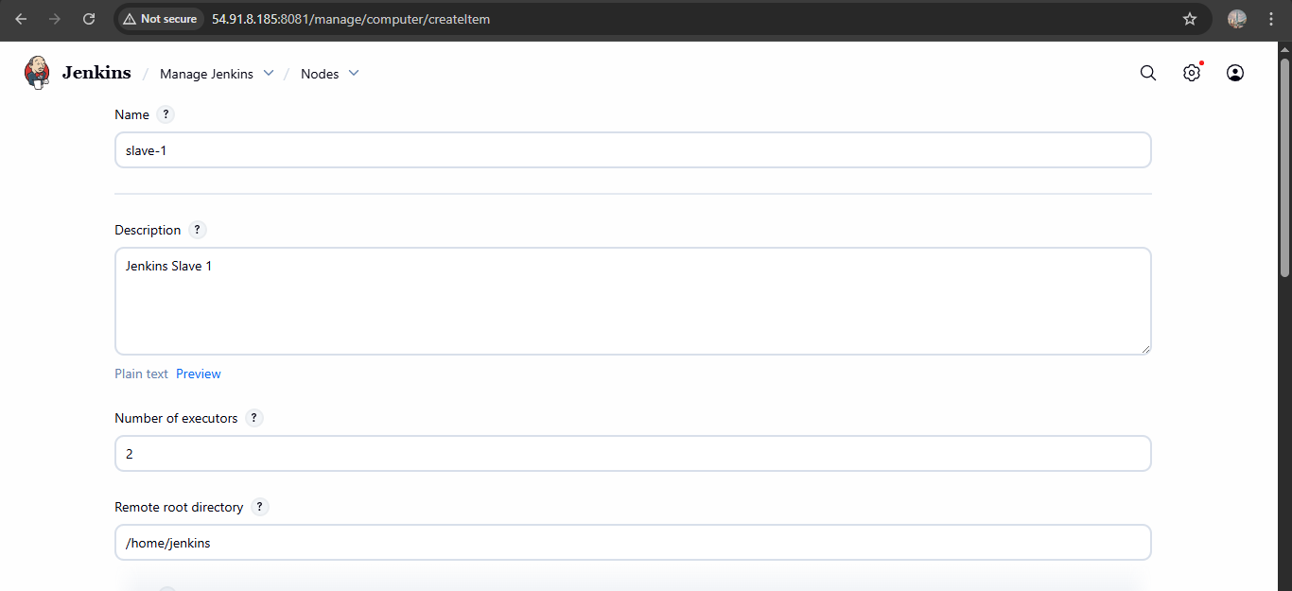

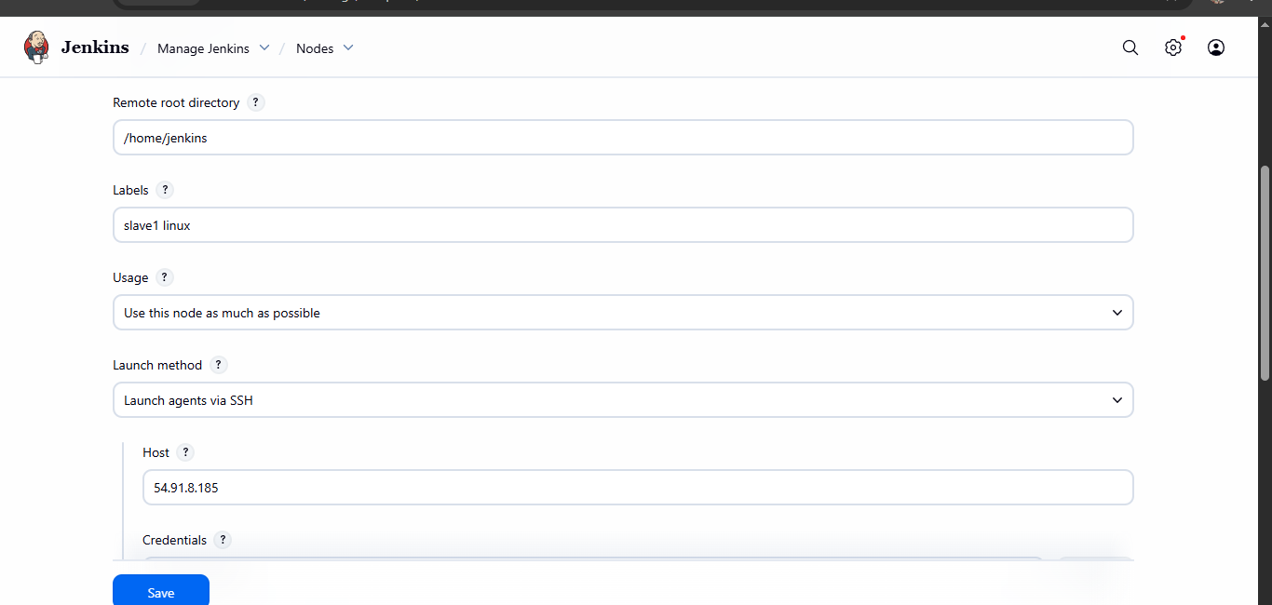

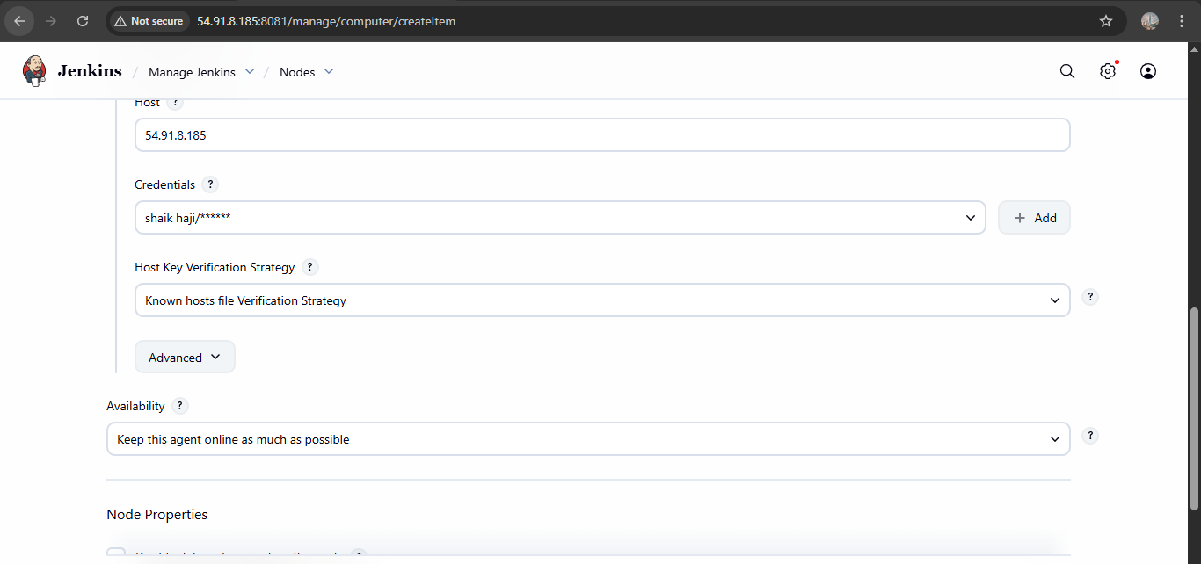

Slave-2

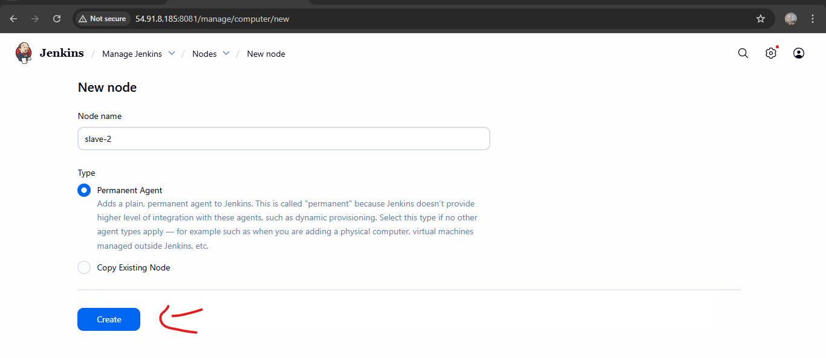

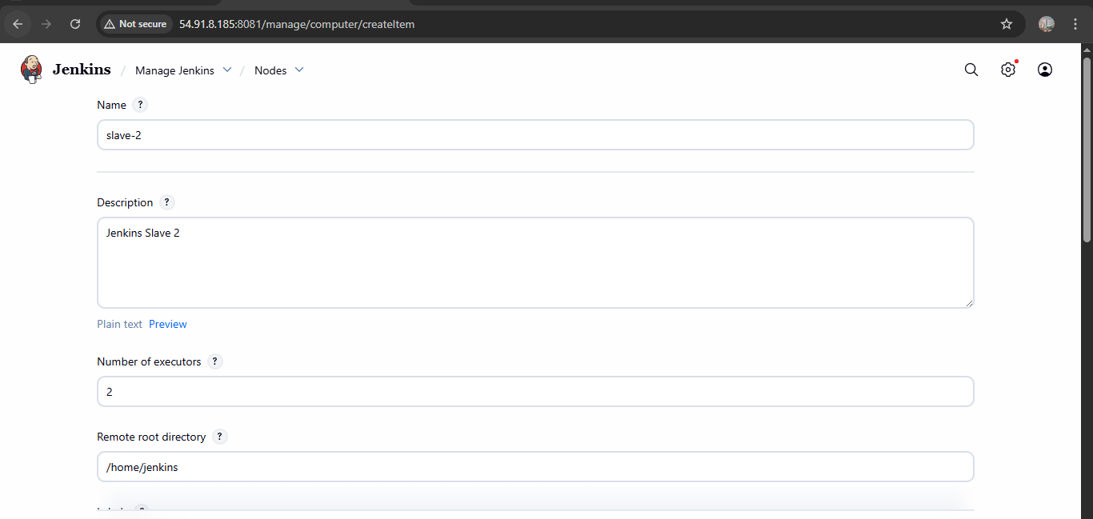

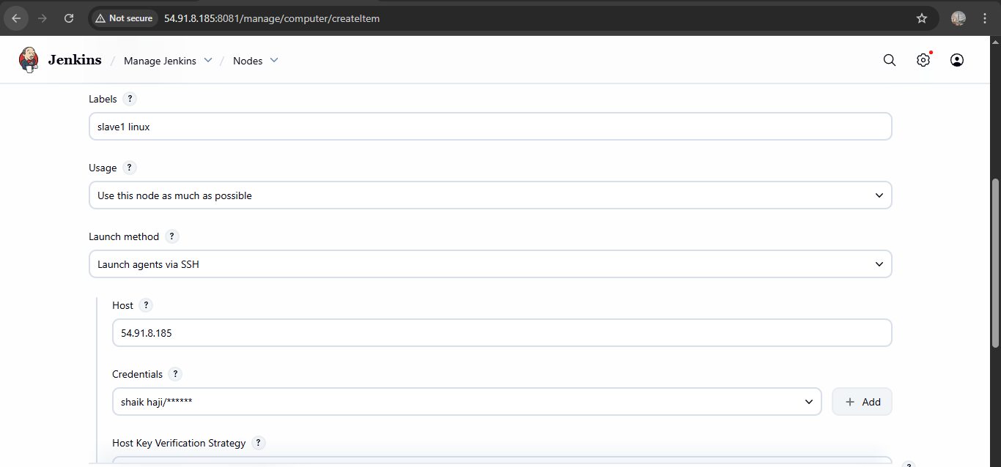

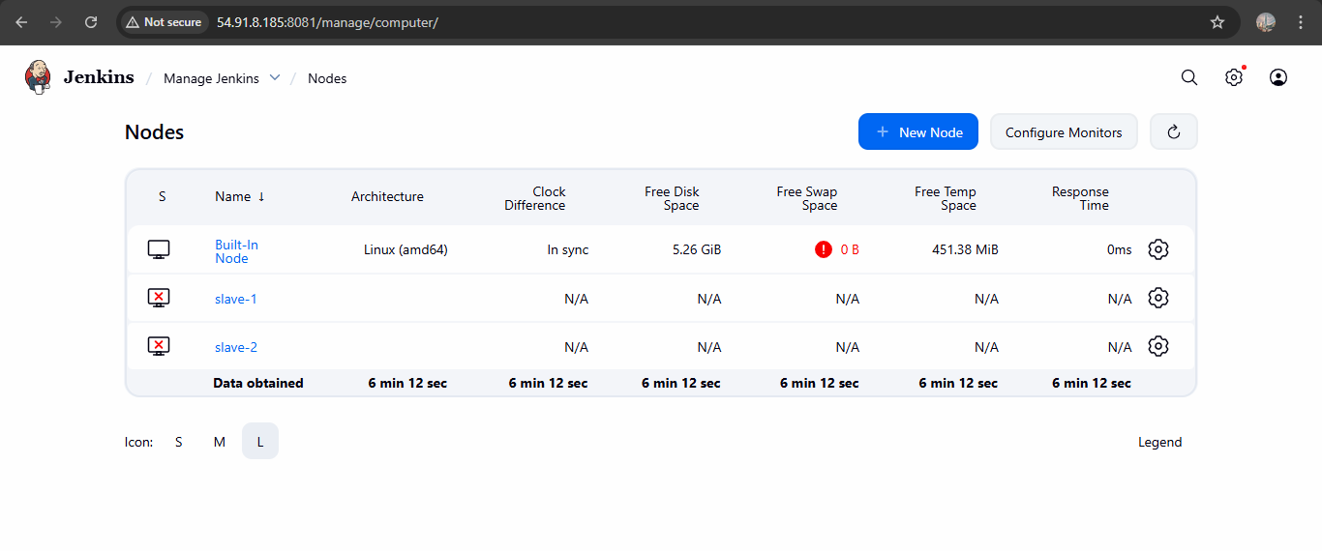

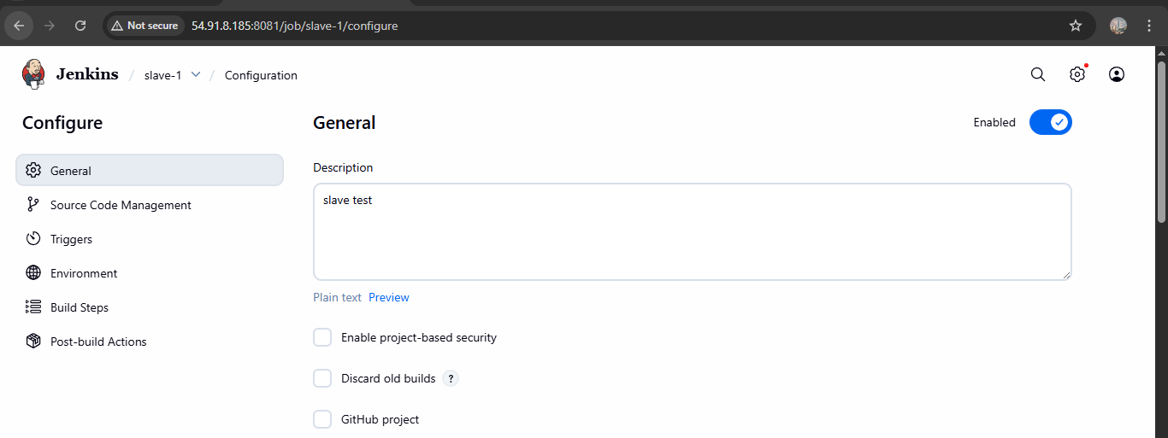

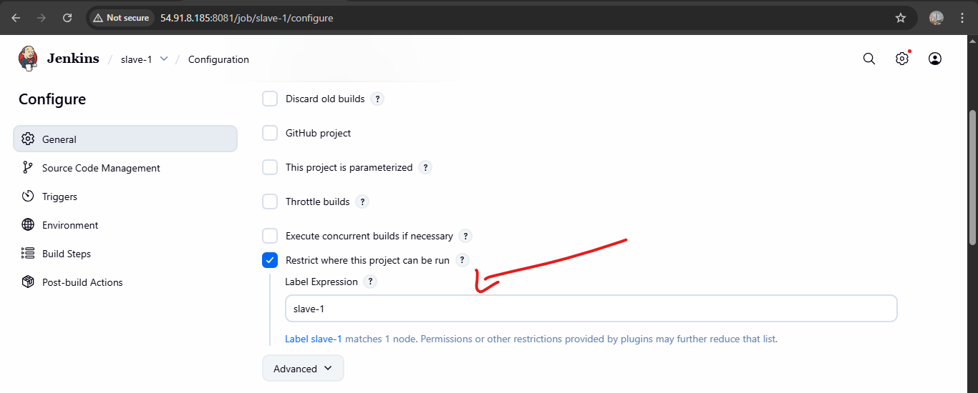

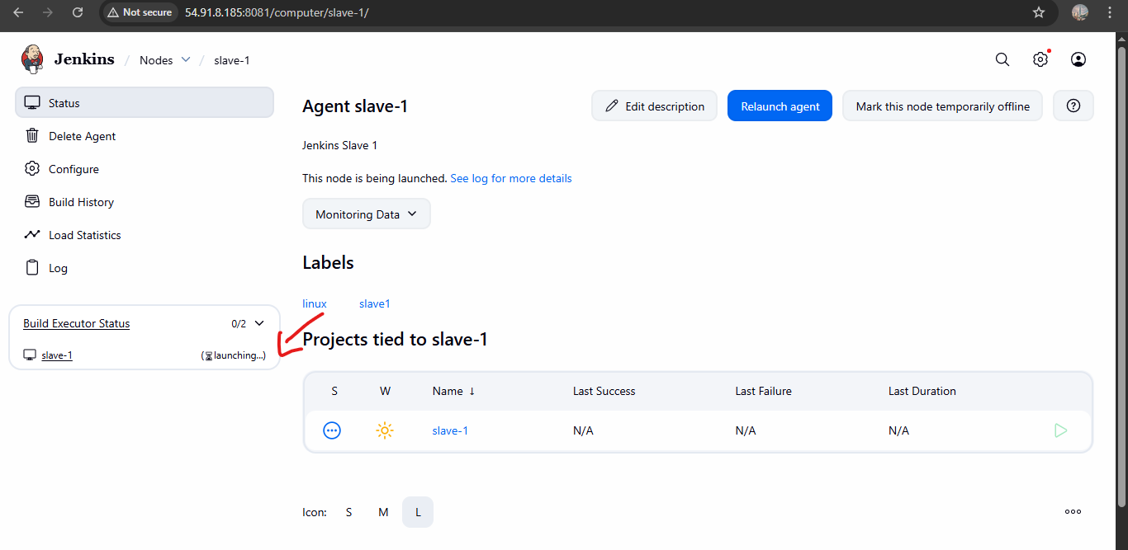

1. Configure webhooks to Jenkins job.

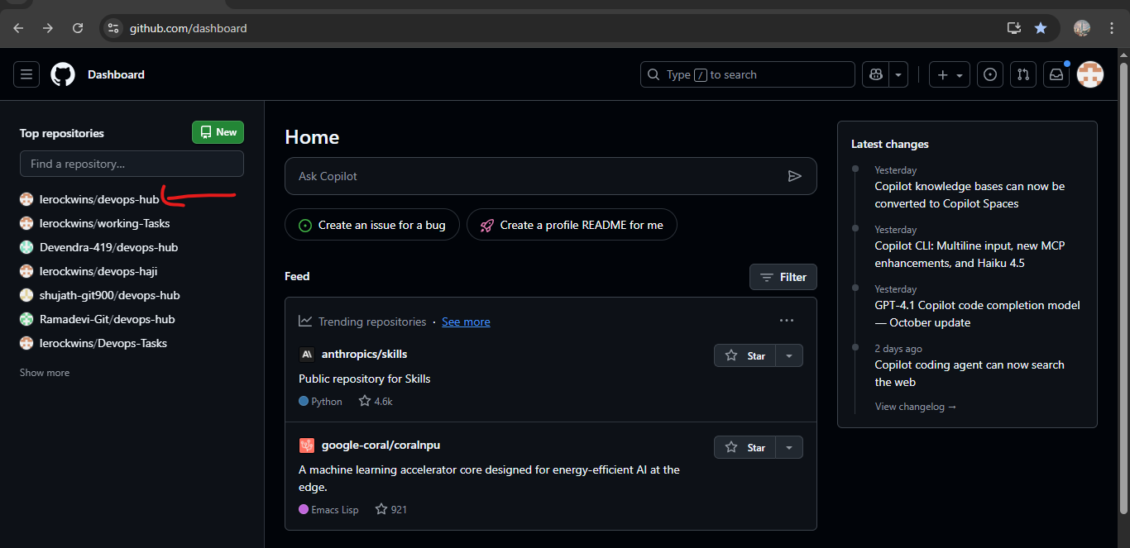

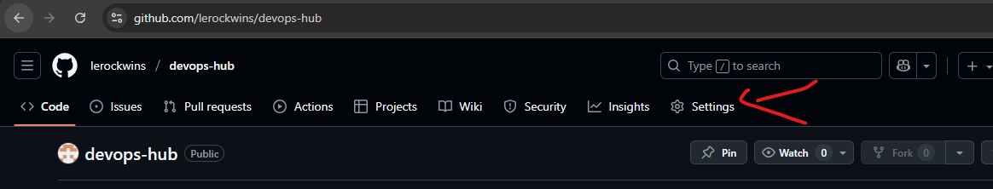

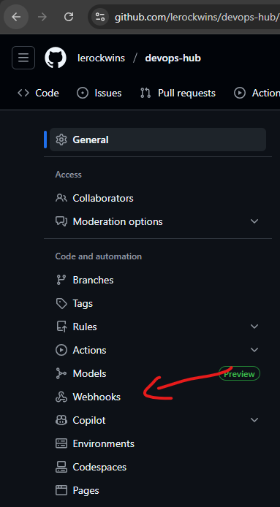

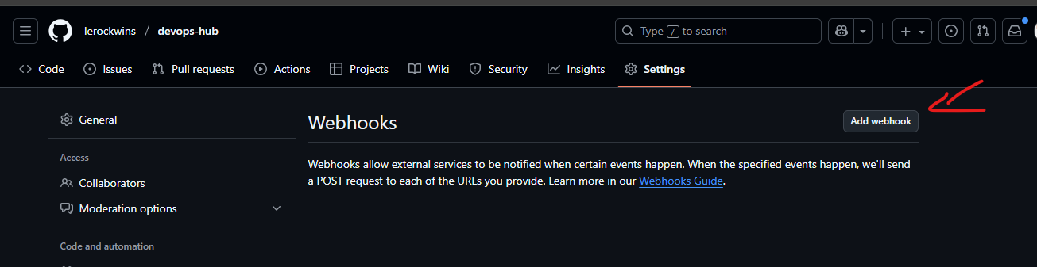

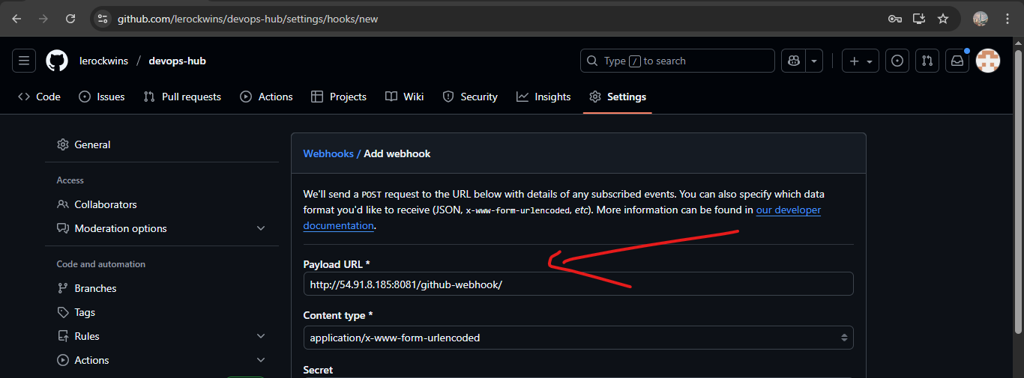

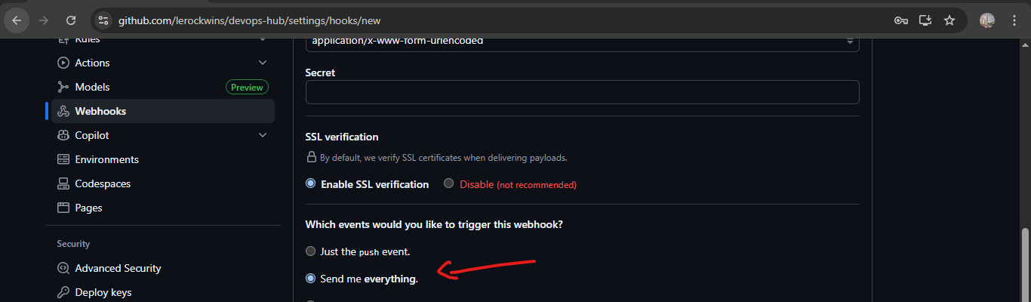

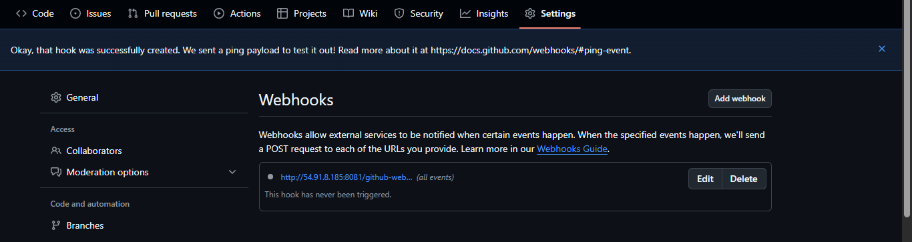

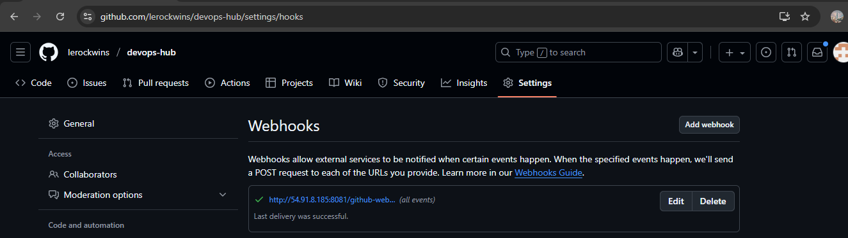

1. Configure poll scm and build periodical options in Jenkins job.

Build periodically option:

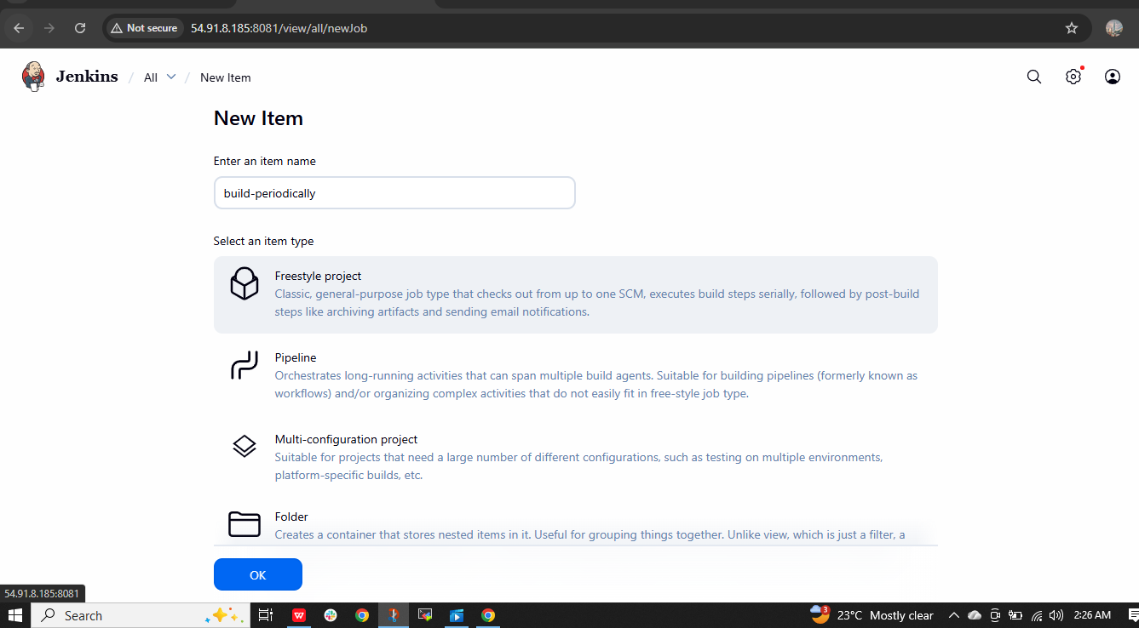

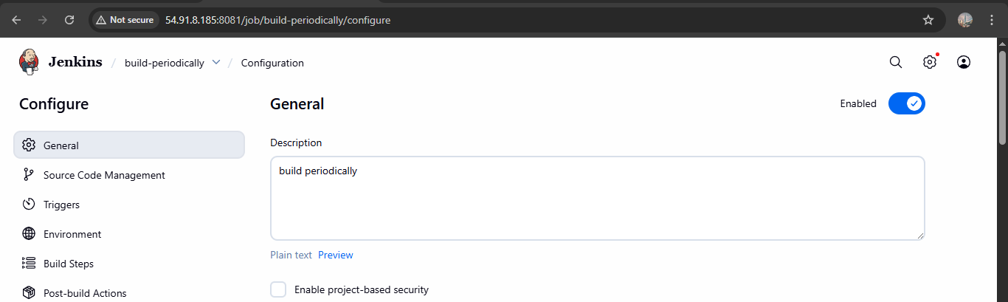

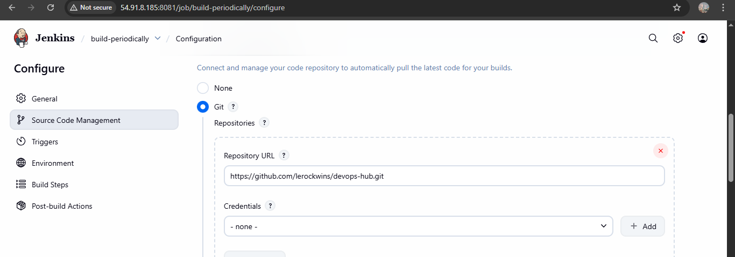

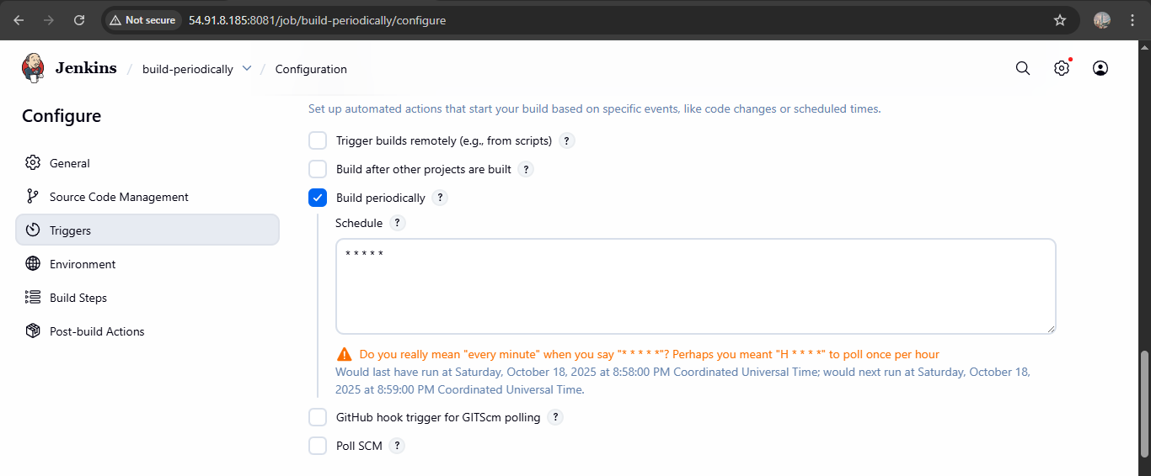

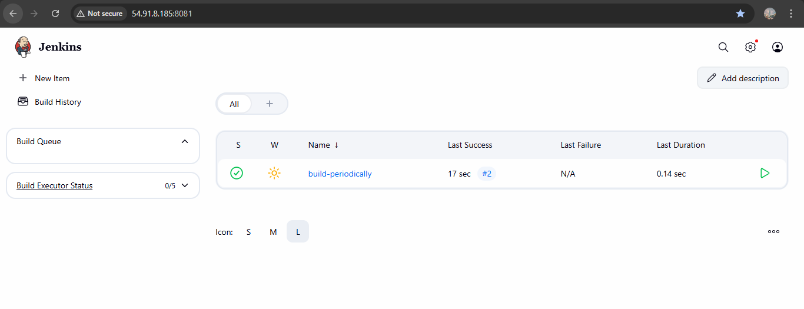

Poll scm:

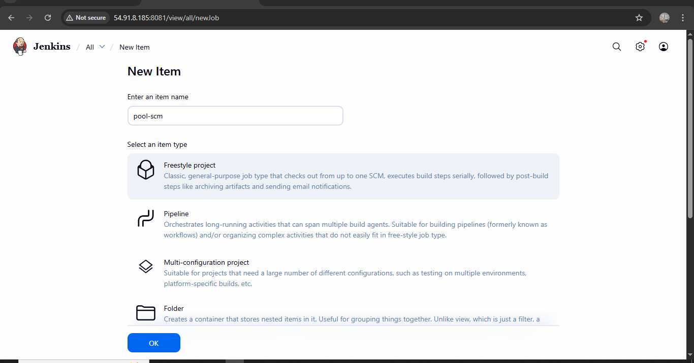

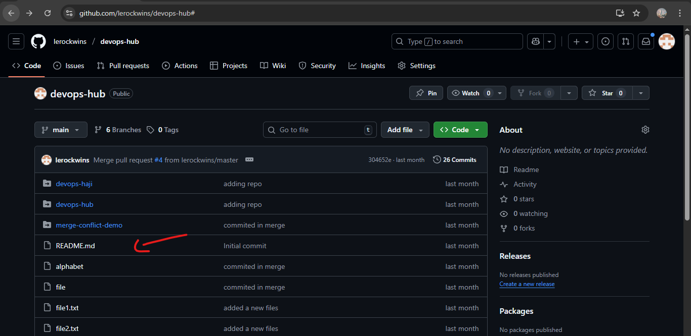

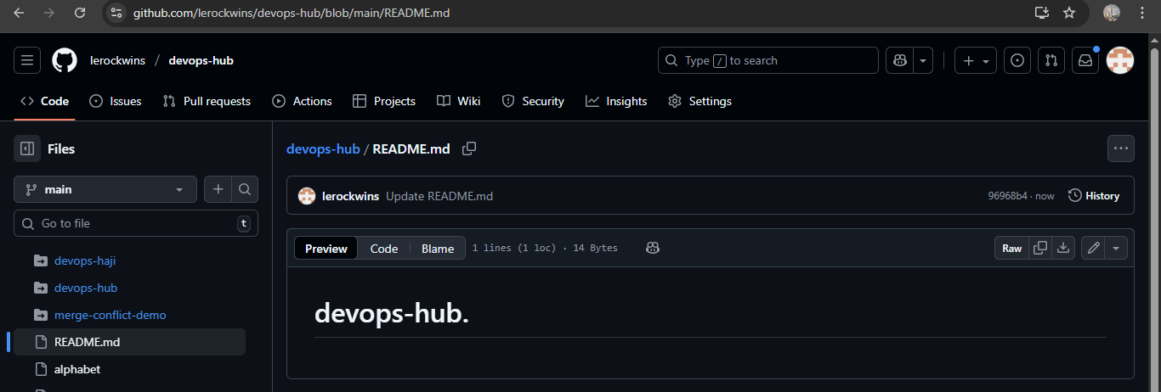

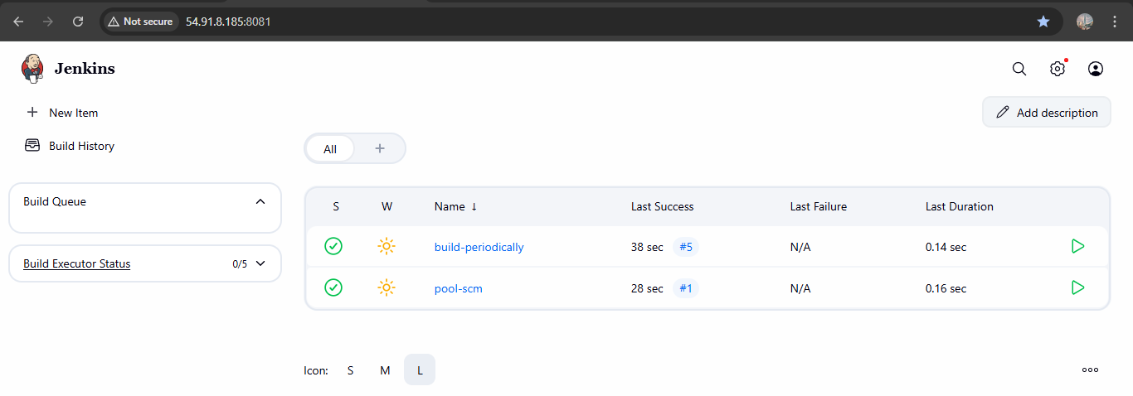

1. Take backup of Jenkins server by using bash script.

Process of back up:

* mkdir -p /backup/jenkins
* vi/usr/local/bin/jenkins_backup.sh

Script:

#!/bin/bash

# Variables

JENKINS_HOME="/var/lib/jenkins"

BACKUP_DIR="/backup/jenkins"

DATE=$(date +'%Y-%m-%d_%H-%M-%S')

BACKUP_FILE="$BACKUP_DIR/jenkins_backup_$DATE.tar.gz"

# Create backup directory if not exists

mkdir -p "$BACKUP_DIR"

# Stop Jenkins service (optional but safer)

echo "Stopping Jenkins service..."

systemctl stop jenkins

# Take backup

echo "Taking backup of Jenkins directory..."

tar -czvf "$BACKUP_FILE" "$JENKINS_HOME"

# Start Jenkins service back

echo "Starting Jenkins service..."

systemctl start jenkins

echo "Backup completed successfully!"

echo "Backup file stored at: $BACKUP_FILE"

* Then chmod +x /usr/local/bin/jenkins_backup.sh
* sudo /usr/local/bin/jenkins_backup.sh

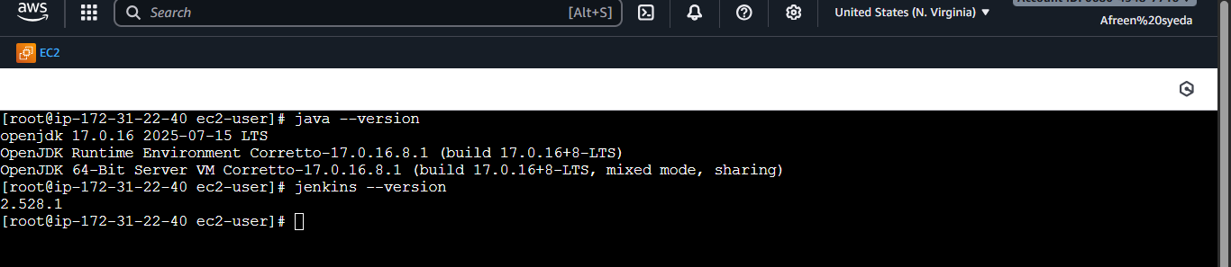

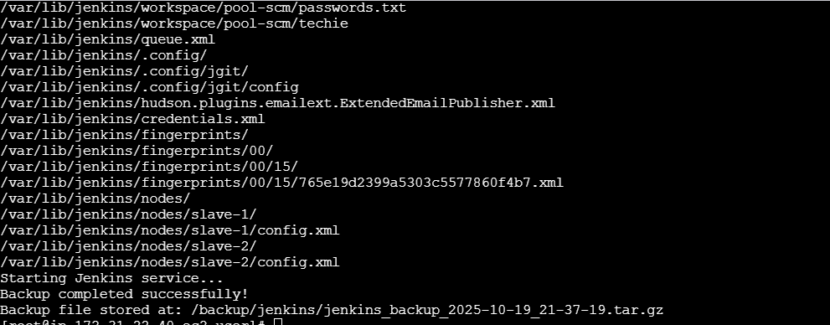

1. Take backup of Jenkins using rethin backup plugin.

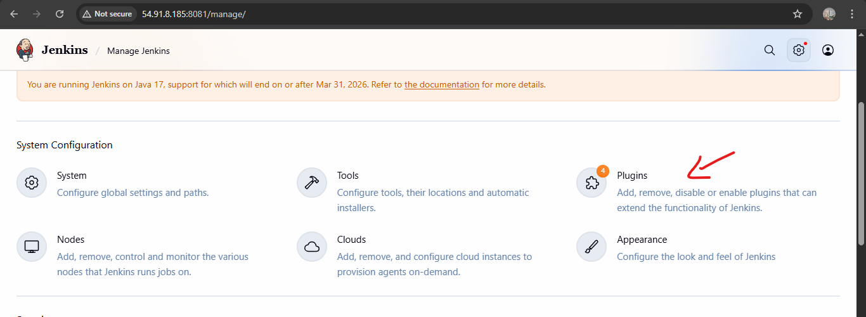

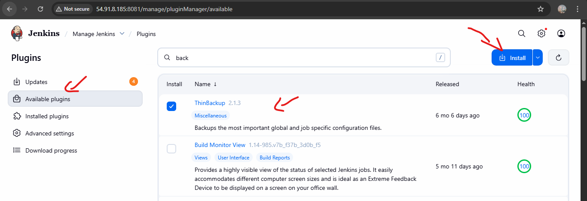

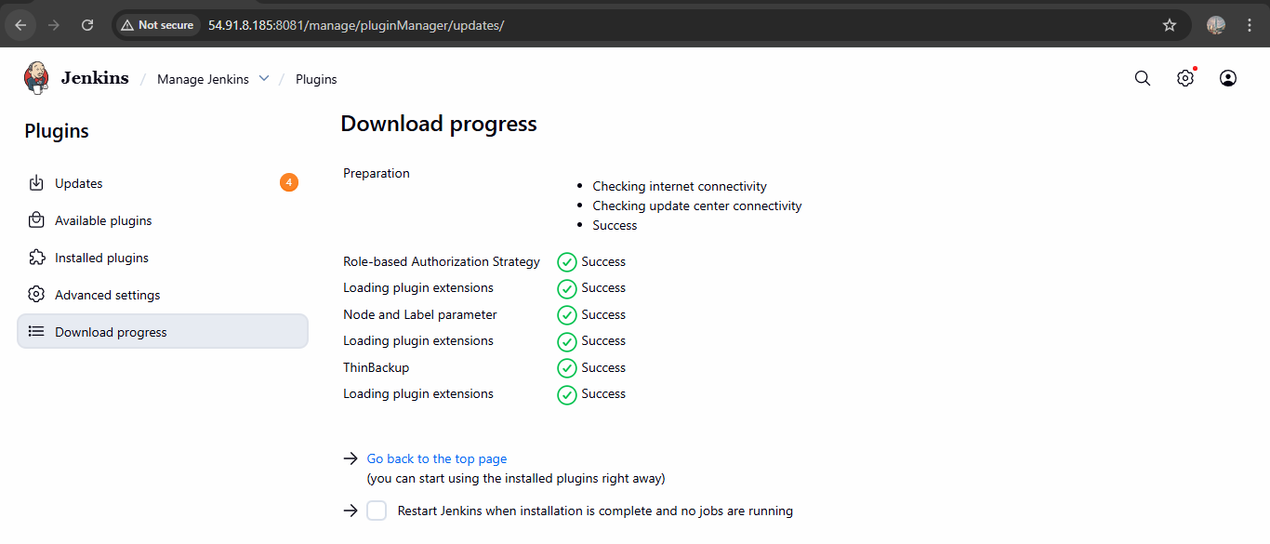

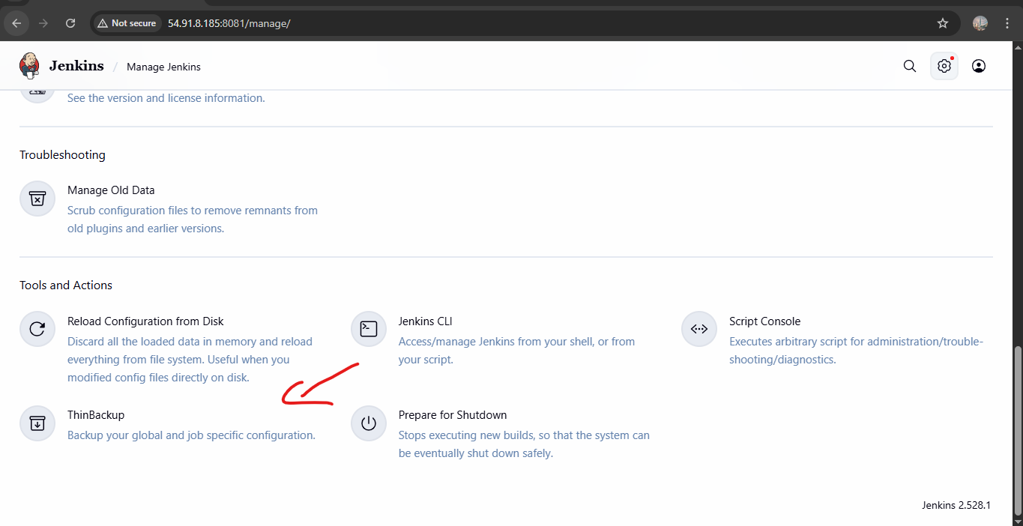

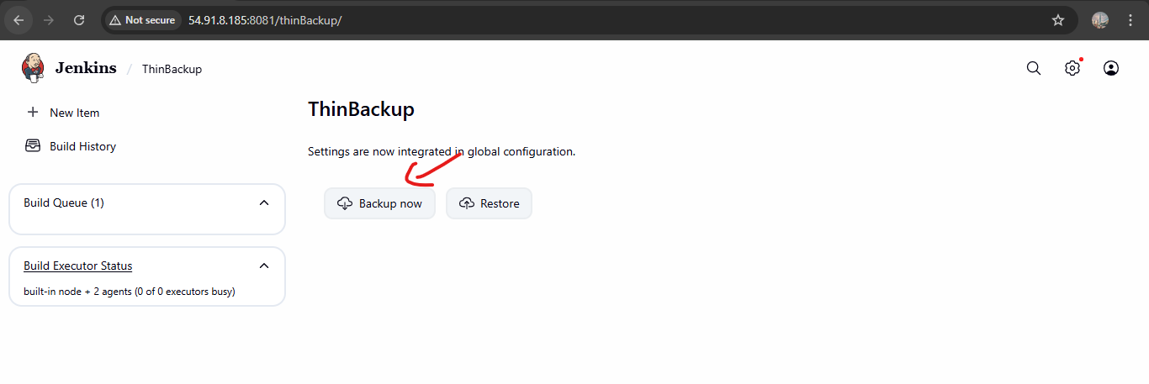

1. Setup a new Jenkins server and dump the backup taken in task4.

